**REGISTRATION FORM**

**SEMESTRAL FEES**

**PLAN**

**A**

REGISTRAR'S COPY

Kasiglahan Village, San Jose, Rodriguez, Rizal Tel No.: (02)2968667/ (02)3959731

Tuition Fee

Admission Fee

Athletic Fee

1,575.00

0.00

**LAST NAME**

**FIRST NAME**

**MIDDLE NAME**

<LNAME>

<FNAME>

<MI>

50.00

**STUDENT NUMBER**

**<SNUM>**

**COURSE**

**ACADEMIC YEAR**

**SEMESTER**

**YEAR LEVEL**

Computer Fee

Cultural Fee

1,000.00

75.00

<COURSE>

AY <AY>

1st

<Y>year-REGULAR

**CODE**

**SUBJECTDESCRIPTION**

**YEAR-SECTION**

**UNITS DAYS**

**TIME**

**ROOM**

Development Fee

Guidance Fee

300.00

100.00

0.00

ELECT 3 (IPT) IT Elective 3 (Integrative Programming and Technologies 2)

BSIT <S>

BSIT <S>

BSIT <S>

BSIT <S>

BSIT <S>

BSIT <S>

BSIT <S>

3

3

3

3

3

3

3

GE RIZAL

HC1

The Life and Works of Jose Rizal

Human Computer Interaction

IAS1

IM2

Information Assurance and Security 1

Data Warehousing and Data Mining

Quantitative Methods

Handbook Fee

Laboratory Fee

Library Fee

0.00

QM

SA

System Administration and Maintenance

500.00

75.00

Medical & Dental Fee

Registration Fee

School ID Fee

75.00

0.00

**TOTAL**

ASSESSED BY

Tracking no#.

**ADVISER**

**Total Units**

**REGISTRAR**

Engr. Rhona M. Segui

**3,750.00**

Patrolla03-16-22

**21**

**DATE**

Note:

*19-00627*

<EMAIL>

Designedby: TEAMMIS

ASSESMENTver. 2nd-19-20

**REGISTRATION FORM**

**SEMESTRAL FEES**

**PLAN**

**A**

Kasiglahan Village, San Jose, Rodriguez, Rizal Tel No.: (02)2968667/ (02)3959731

CASHIER'S COPY

Tuition Fee

1,575.00

**LAST NAME**

**FIRST NAME**

**MIDDLE NAME**

Admission Fee

Athletic Fee

0.00

<LNAME>

<FNAME>

<MI>

50.00

**STUDENT NUMBER**

**<SNUM>**

**COURSE**

**ACADEMIC YEAR**

**SEMESTER**

**YEAR LEVEL**

Computer Fee

Cultural Fee

1,000.00

75.00

<COURSE>

AY <AY>

1st

<Y>year-REGULAR

**CODE**

**SUBJECTDESCRIPTION**

**YEAR-SECTION**

**UNITS DAYS**

**TIME**

**ROOM**

Development Fee

Guidance Fee

300.00

100.00

0.00

ELECT 3 (IPT) IT Elective 3 (Integrative Programming and Technologies 2)

BSIT <S>

BSIT <S>

BSIT <S>

BSIT <S>

BSIT <S>

BSIT <S>

BSIT <S>

3

3

3

3

3

3

3

GE RIZAL

HC 1

The Life and Works of Jose Rizal

Human Computer Interaction

IAS 1

IM2

Information Assurance and Security 1

Data Warehousing and Data Mining

Quantitative Methods

Handbook Fee

Laboratory Fee

Library Fee

0.00

QM

SA

System Administration and Maintenance

500.00

75.00

Medical & Dental Fee

Registration Fee

School ID Fee

75.00

0.00

**TOTAL**

ASSESSED BY

Tracking no#.

**ADVISER**

**Total Units**

**REGISTRAR**

Engr. Rhona M. Segui

**3,750.00**

Patrolla03-16-22

**21**

**DATE**

Note:

*19-00627*

<EMAIL>

Designedby: TEAMMIS

ASSESMENTver. 2nd-19-20

**REGISTRATION FORM**

**SEMESTRAL FEES**

**PLAN**

**A**

STUDENT'S COPY

Kasiglahan Village, San Jose, Rodriguez, Rizal Tel No.: (02)2968667/ (02)3959731

Tuition Fee

Admission Fee

Athletic Fee

1,575.00

0.00

**LAST NAME**

**FIRST NAME**

**MIDDLE NAME**

<LNAME>

<FNAME>

<MI>

50.00

**STUDENT NUMBER**

**<SNUM>**

**COURSE**

**ACADEMIC YEAR**

**SEMESTER**

**YEAR LEVEL**

Computer Fee

1,000.00

<COURSE>

AY <AY>

1st

<Y> year-REGULAR

Cultural Fee

Development Fee

Guidance Fee

75.00

300.00

100.00

0.00

**CODE**

**SUBJECTDESCRIPTION**

**YEAR-SECTION**

**UNITS DAYS**

**TIME**

**ROOM**

ELECT 3 (IPT) IT Elective 3 (Integrative Programming and Technologies 2)

BSIT <S>

BSIT <S>

BSIT <S>

BSIT <S>

BSIT <S>

BSIT <S>

BSIT <S>

3

3

3

3

3

3

3

GE RIZAL

HC1

The Life and Works of Jose Rizal

Human Computer Interaction

IAS1

IM2

Information Assurance and Security 1

Data Warehousing and Data Mining

Quantitative Methods

Handbook Fee

Laboratory Fee

Library Fee

0.00

QM

SA

System Administration and Maintenance

500.00

75.00

Medical & Dental Fee

Registration Fee

School ID Fee

75.00

0.00

**TOTAL**

ASSESSED BY

Tracking no#.

**ADVISER**

**Total Units**

**REGISTRAR**

Engr. Rhona M. Segui

**3,750.00**

Patrolla03-16-22

**21**

**DATE**

**7**

Note:

*19-00627*

<EMAIL>

CdMFORMNO. 120

Designedby: TEAMMIS

<LNAME>

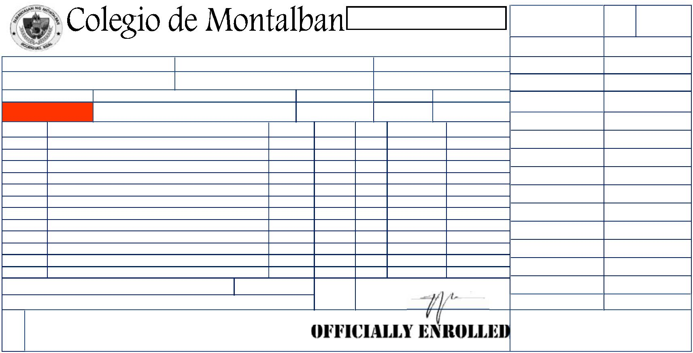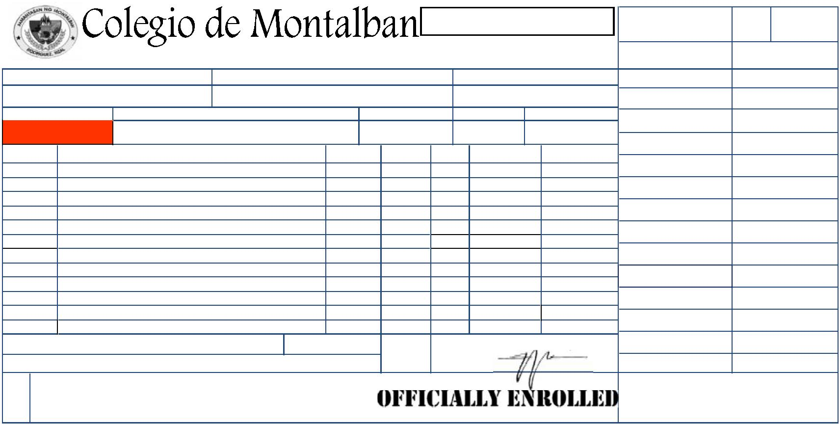ooxWord://word/media/image3.jpegooxWord://word/media/image4.jpegooxWord://word/media/image5.jpegooxWord://word/media/image6.jpegooxWord://word/media/image7.jpegooxWord://word/media/image8.jpegooxWord://word/media/image9.jpegooxWord://word/media/image10.jpeg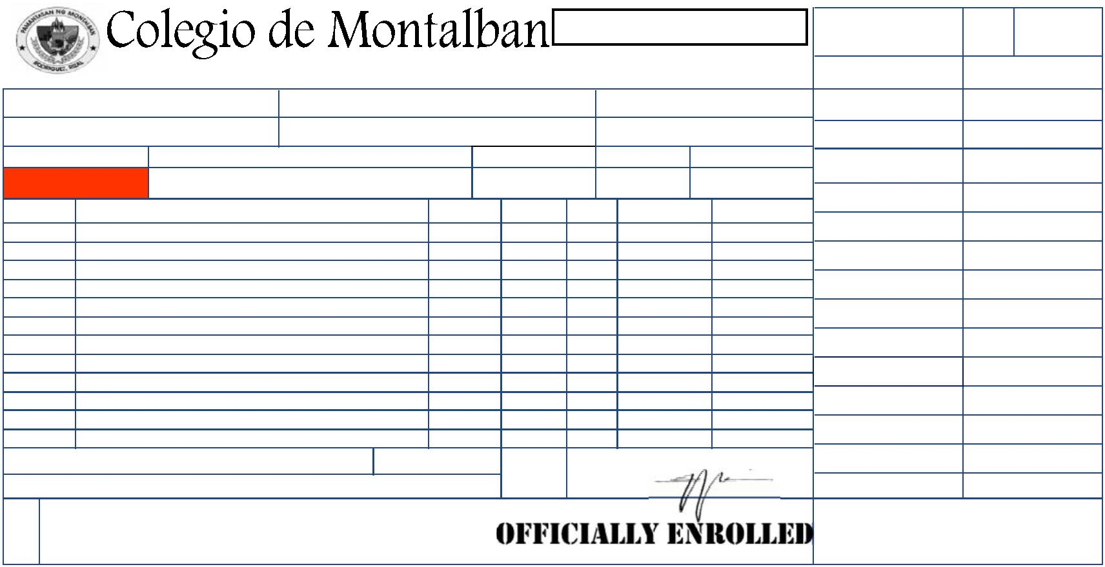ooxWord://word/media/image12.jpegooxWord://word/media/image13.jpegooxWord://word/media/image14.jpegooxWord://word/media/image15.jpegooxWord://word/media/image16.jpegooxWord://word/media/image17.jpegooxWord://word/media/image18.jpegooxWord://word/media/image19.jpegooxWord://word/media/image20.jpegooxWord://word/media/image21.jpeg